1st problem screen shoots

1.

If (\*\*(\*[\*])\*\*\*\*) is added

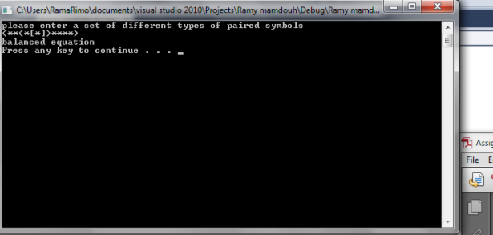

2. if [{}\*\*[]\*\*()]\*\* is added

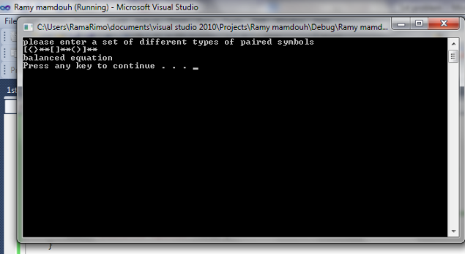

3. if ((\*{\*)\*}) is added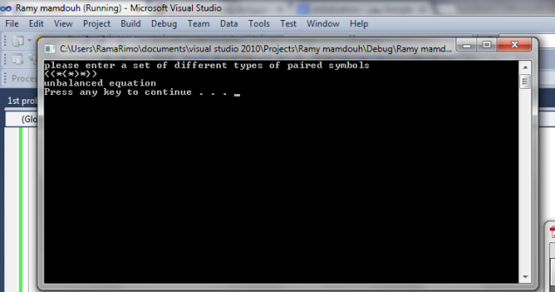

4. if [()\*\*\*[]\*\*\*{\*(\*)} is added. 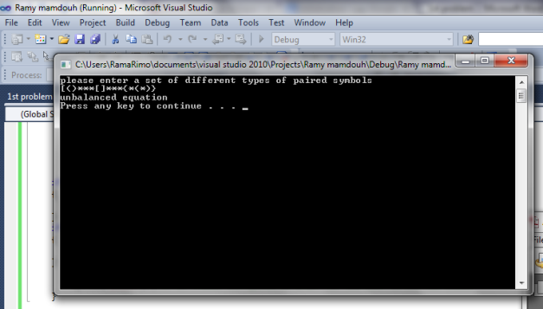

Code: #include<iostream>

#include<string>

#include<cstdlib>

#include<cmath>

using namespace std ;

int const size = 10; //stack size=10

char thestack[size] ;//initialization of the stack

int top= -1 ;

bool isfull()//checking if the stack is full

{

if(top==size-1)

{ return true ; }

return false ;

}

bool isempty() //checking if the stack is empty

{

if(top==-1)

{

return true ;

}

return false ;

}

int pop() //getting one element outside of the stack

{

return thestack[top--] ;

}

void push (int element ) //putting one element in the stack

{

if(!isfull())

{

thestack[++top]=element ;

}

}

void main()

{

string s ; //declaration of a string

cout<<"please enter a set of different types of paired symbols "<<endl ;

cin>>s ;

for(int i=0 ; i<s.length() ;i++)//checking every charchter in the string //s.length() to stop when the charchters in the string are finished

{

//if the char.=(,{,[ push it to the stack

if((s.at(i)=='{')||(s.at(i)=='[')||(s.at(i)=='('))

{

push(s.at(i)) ;

}

//if the charchter is found=} and the top of the stack containing the opposite sign pop the last one

if((s.at(i)=='}')&&(thestack[top]=='{'))

{

pop() ;

}

//if the charchter is found=) and the top of the stack containing the opposite sign pop the last one

if((s.at(i)==')')&&(thestack[top]=='('))

{

pop() ;

}

//if the charchter is found=] and the top of the stack containing the opposite sign pop the last one

if((s.at(i)==']')&&(thestack[top]=='['))

{

pop() ;

}

}

if(top==-1)//stack is empty every element is popped which means the equation is balanced

{

cout<<"balanced equation"<<endl ;

}

if(top>-1) //stack contains at least one char which means that the equation is not balanced

{

cout<<"unbalanced equation"<<endl ;

}

system("pause") ; // to freeze the system in order for the user to see his answer

}